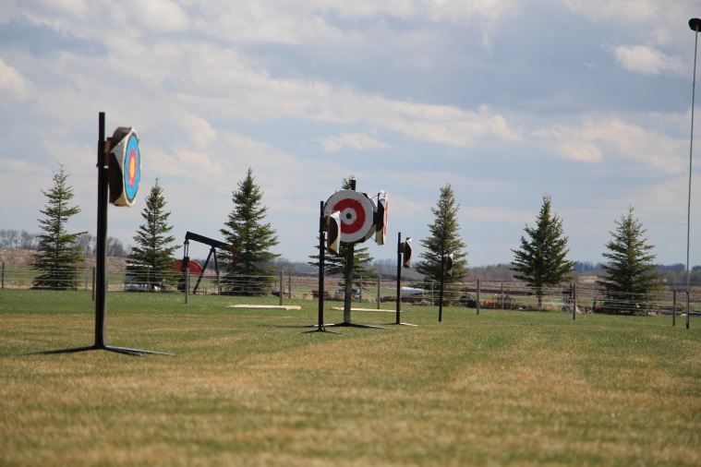
Presented
by

door (and outdoor if possible)
Meet and Compete MA Series
Incorporating IHAA Postal Matches and Grading events
Dates:
July 28 Postal Match
August 25 P.M. + Grading Event
September 28 Postal Match
October 26 Postal Match
Kaspian Equestrian
Hosted by

Registration Limited to 12 Mounted Archers
Archer |  | Email |  | Age < 18
Address |  |  |  | Phone
Horse name |  |  | Mounted | $40
AEF # |  |  | Ground archery | $20
Event date |  |  | Mounted + Ground | $50
Gait | Walk Trot Canter |  | Horse use/course | $20
Postal Match | 1 |  | BBQ lunch for guest | $10
Postal match | 2 |  | Overnight Stabling | $25
Grading | 1 Hungarian 90 | n/a | 3rd run if also grading | $20
Grading | 2 Korean 2-3 90 | n/a | GST included | Total
Competition Fee includes: Day stall, Shavings, Hay, BBQ, Score Submission.
Send entries and E-transfer fees to kaspianentries@gmail.com Spots will not be held until payment is received.
Signed waiver to be included with registration. AEF or equivalent provincial membership is required.
If the roads are too icy to travel fees will be refunded.
Location: Kaspian Equestrian / Rock-N-Rail Ranch 33375 Rge Rd 21 Intersection of Twp Rd 334 and Rge Rd 21 4 miles north and 2 west from Olds Hospital.
For information visit kaspianequestrian.com FB Kaspian Archery or email kaspianarchery@gmail.com.
February 10, 2019, 8am to 4pm

